**YouTube Dynamic Video App using Django**

**Frontend:**

1. The frontend is developed using html and css

**Output:**

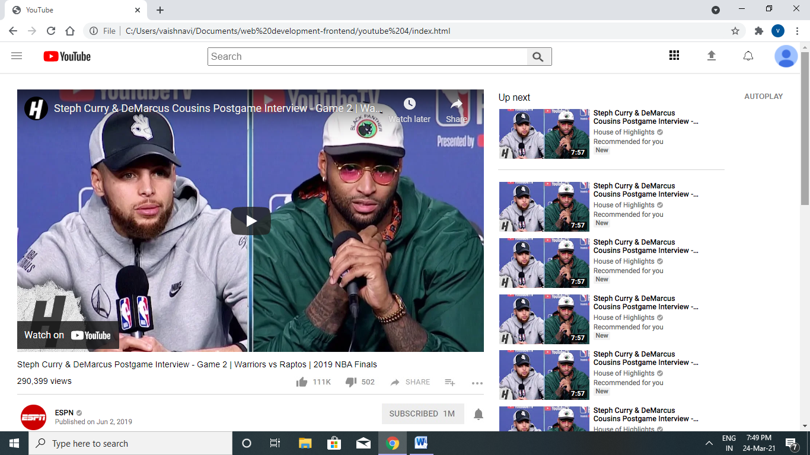

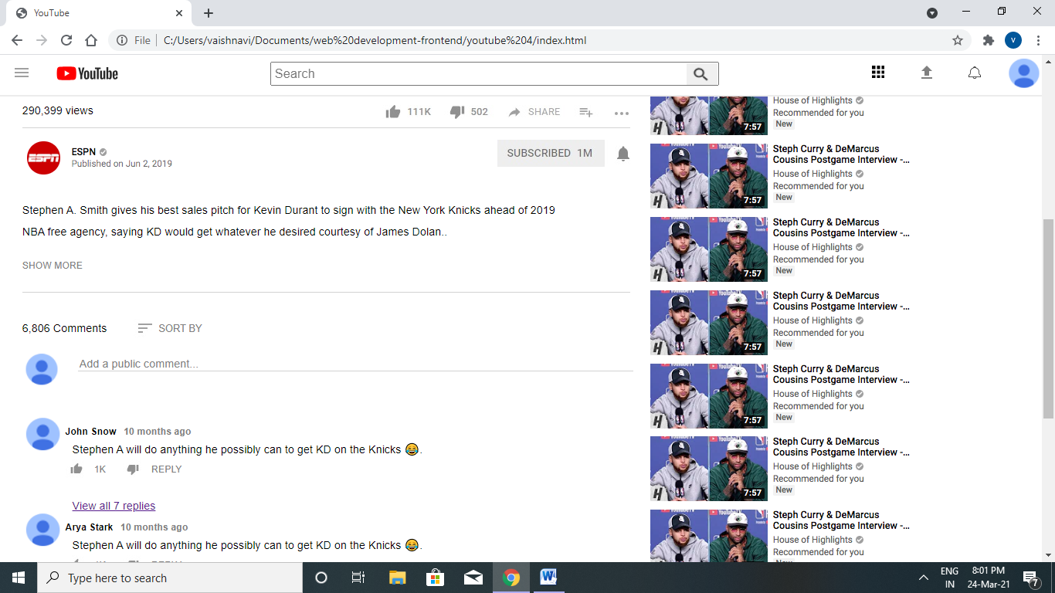

1. The html and css files are connected with django in order to make the app dynamic where the video can be updated dynamically.

* The project youtube is created using the command

**django-admin startpoject youtube**

This will create a "myproject" folder with the following structure –

youtube/

manage.py

__init__.py

settings.py

urls.py

wsgi.py

* An application is created that is an app is started using the command

**python manage.py startapp my_youtube**

This will create a “my_youtube” folder with the following structure-

my_youtube/

__init__.py

admin.py

models.py

tests.py

views.py

* The Admins interface is started

**python manage.py migrate**

**python manage.py createsuperuser**

To start the Admin Interface we have configured a URL for our admin interface. This helps the admin to change the data dynamically.In our cases the admin can update the videos.

